1. **Agenda**:
   1. Building our first Route.
2. **What is a Route**?
3. Let’s create a Timer Router to schedule things and run at regular intervals.
4. To build a Router, we need to extend the class from **RouterBuilder**.  
   
5. **RouterBuilder.configure()** is the method where we create all our routes.
6. **What is a Route**?
   1. Suppose we want to listen to a Queue.
   2. Then we want to do some transformations on the data from the Queue.
   3. Then we want to store the date final results to a DB.  
      So, this sequence of steps is **called Route**.
7. Here in this sequence, we have **two endpoints**.
   1. **Queue** from where we’re receiving data.
   2. **DB** where we’re sending data.
8. For the time being, we will not use Queue but Timer to trigger msgs & we will not use DB to store them but will log them.

We will use **Timer** and **Log** as the channels to simplify things instead of **Queue** and **DB**.  
But as we go further, we will start using Queue and DB.

1. Let’s start writing our Route.
2. There are a lot of methods present inside the **RouterBuilder** class to build a route.  
   When we start defining a route, we start specifying the starting point of the route (Source) which is actually endpoint from where we get msgs.
   1. RouterBuilder**.from**(“timer:first-timer”);
   2. Above we’re creating an endpoint (source from where we have to get the msgs).  
      This is timer endpoint to which we’re listening to now.
   3. **timer**: keyword.  
      **first-timer**: random name.
   4. **Question: Now whenever there is a new msg on the timer endpoint, what do we want to do?**
   5. **Answer**: Actually, we want to send the msgs to a log.
   7. Graphical user interface, text

      Description automatically generated
   8. Timer and Log are two different channels and we’re connecting them together.  
      Once source of msgs and other consumption of msgs.  
      Now assume source can be Java queue and consumption channel can be DB. 😊 We will discuss it later.
   9. **Technical**: Endpoints are called channels. Here timer and log are channels.
   10. **IDE Console Log for route**:
   11. Let’s see the console log for msgs triggered by timer channel.  
       
   12. Between these two different channels as discussed above, we can do things like transformation.
       1. At this point, our msgs are null produced by channel timer.
       2. But we want to produce some meaningful msgs.
       3. For the time being let’s add some constant msgs.
       4. 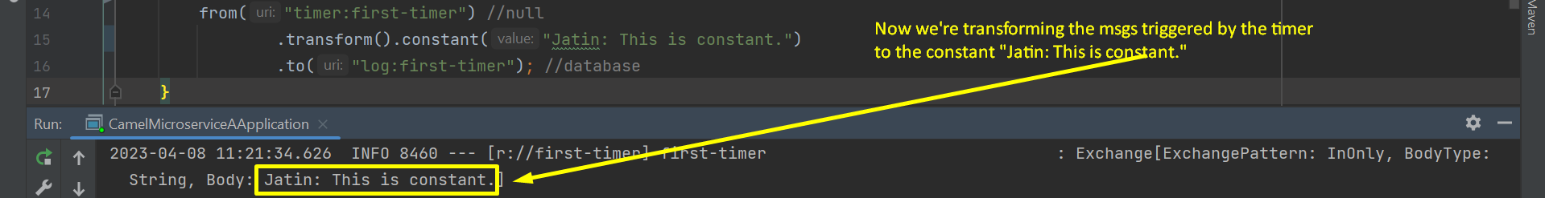
       5. Graphical user interface, text, application, website

          Description automatically generated
3. Things in the real world will not be really this simple.
4. In the next step (lecture), let’s see
   1. how to use Spring Bean as part of our transformation and
   2. how to pick up msgs from Active MQ.